Under the Bridge to Skylight – A Year in Ukraine
Digital Pigment Prints by Stephen Humphreys
Johnson Center for the Arts, January 2024

Dasha’s Graduation – at the Philharmonie after the high school graduation ceremony in Khmelnystkyi. 24 x 36. $450

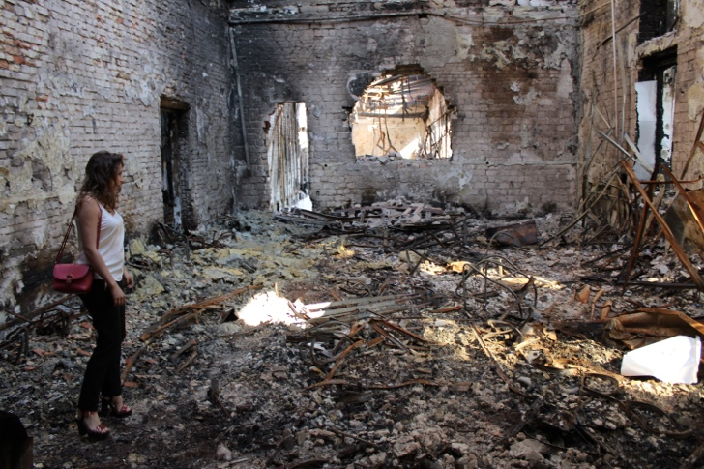
Tetiana’s World – the State Tax University at Irpin according to Wyeth.
24 x 36 Digital Pigment Print $450
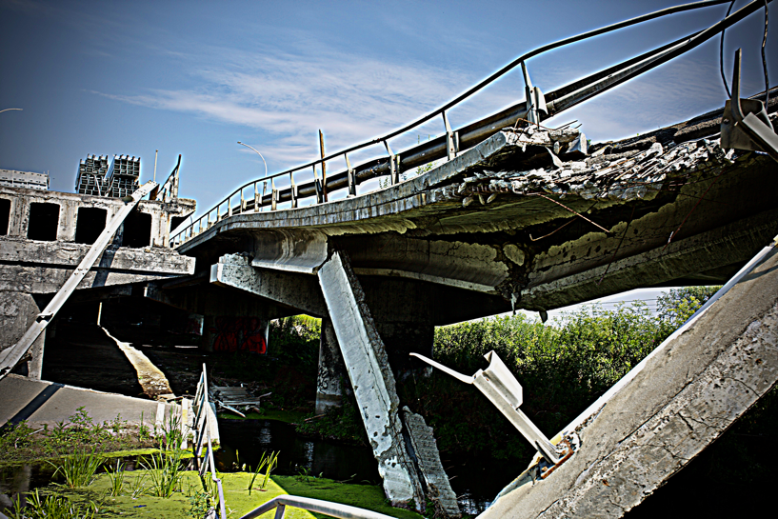
Broken Bridge of the North – destroyed bridge that stopped the Russian advance at Irpin before the Orcs were treated to a fiery unwelcome. 24 x 36. $350
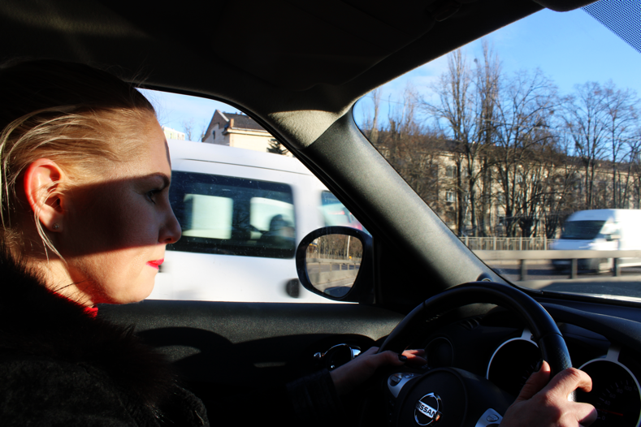
Remain On Time – Vera keeps on schedule on the Kyiv-Irpin Road.
24 x 36 Digital Pigment Print. $250
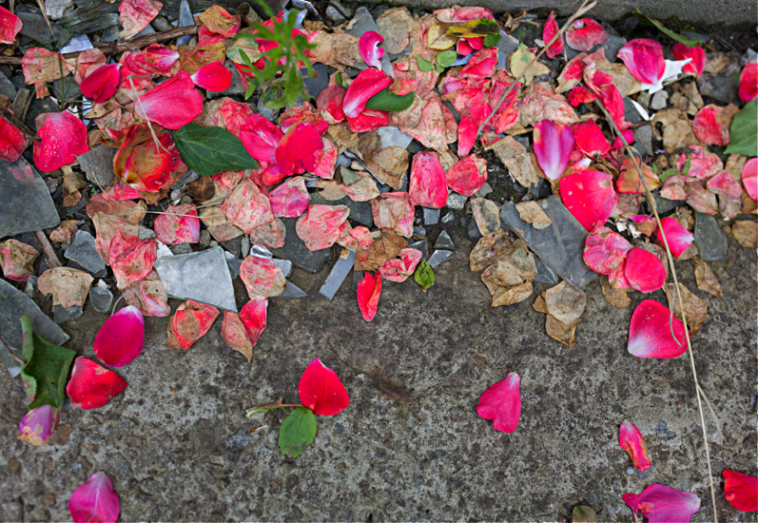
Fallen Petals / Broken Glass – the threshold of a shattered apartment building in Kupiansk. 24x36. $400
Fathers and Sons – how to protect the psyche of the children of Ukraine from the destruction around them. 36 x 24Digital Pigment Print. $450

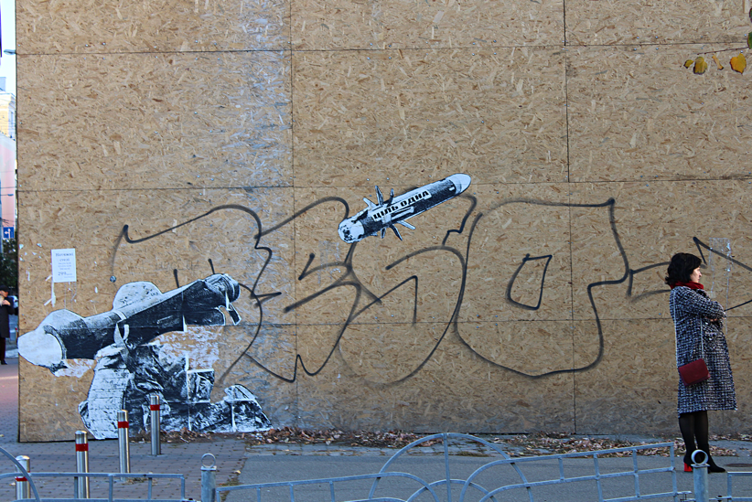
Near Miss – Javelin stenciled over the head of an unsuspecting civilian on Khreshatyk.
24 x 36 Digital Pigment Print. $450
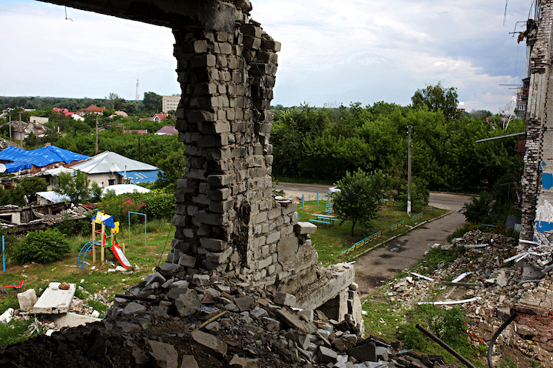
Arc-en-ciel—imagining the bridge across the empty void in a destroyed apartment building in Kupiansk. 24 x 36. $250
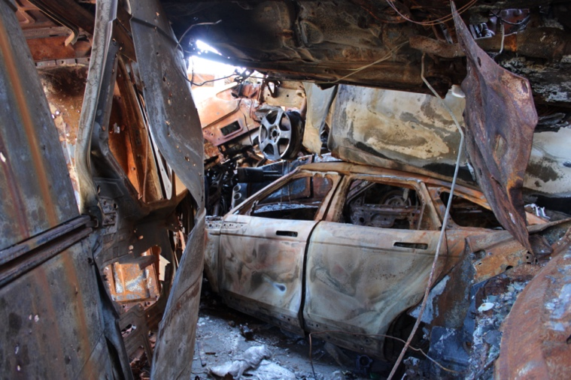

Tunnnel to the Light – one monument to the battle is a heap of destroyed vehicles in a parking lot outside Irpin. 24 x 36 Digital Pigment Print. $350

Fire flags – flames from the Holy Spirit, the Pentecost service at the Church of the Risen Christ in Vinnytsiya. 24 x 36 Digital Pigment Print. $300
Free the Prisoners – jailhouse church service in Vinnytsiya. 24 x 36. $300
Flotsam – a sea of the trifles from the lives of the tenants spread out on the fifth floor of a destroyed apartment building near Kupiansk. 36 x 24 Digital Pigment Print. $450
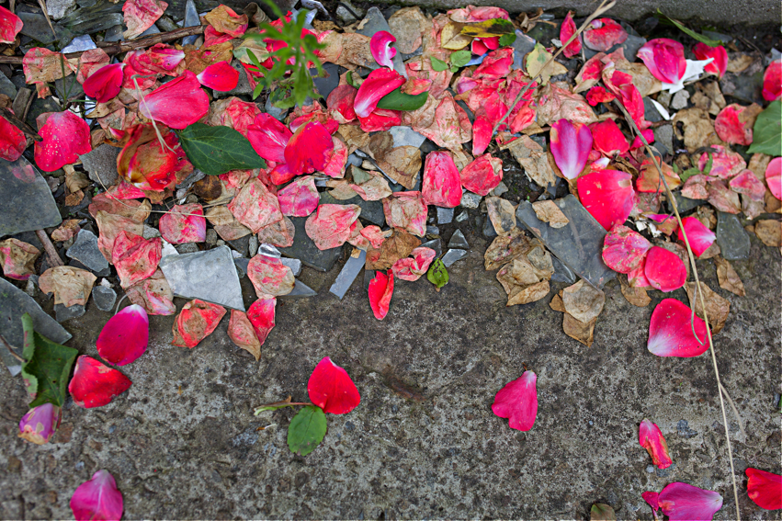
Fallen Petals / Broken Glass – the threshold of a shattered apartment building in Kupiansk.
24 x 36 Digital Pigment Print. $400

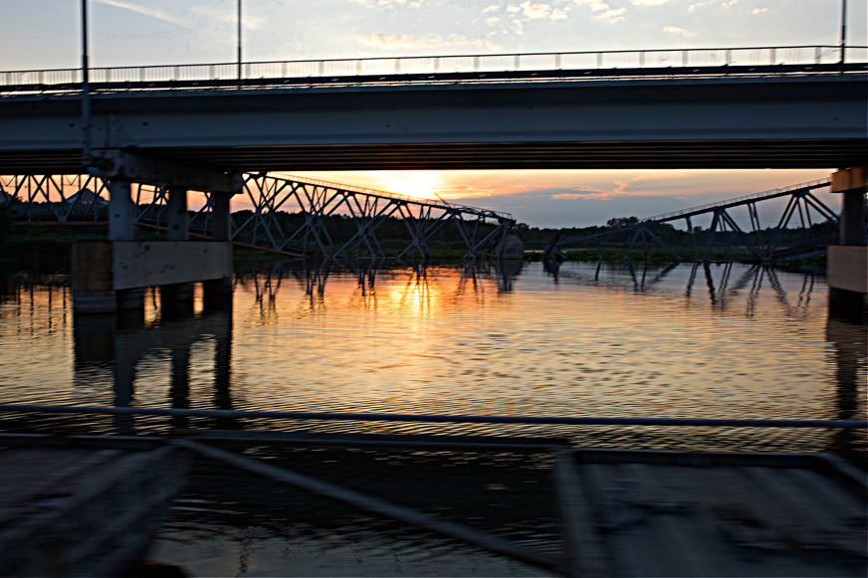
Broken Bridge of the East – sunset at the destroyed bridge near Lyman. This is where the military intelligence battalion first crossed the river to recapture northeaster Ukraine.
24 x 36 Digital Pigment Print. $250

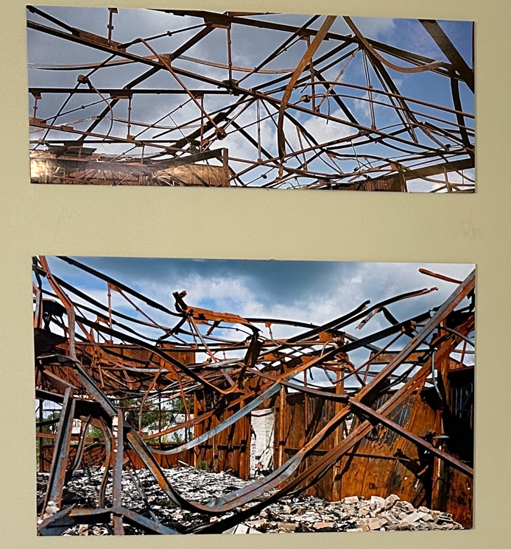
Under the Birdge to Skylight – diptych, apertures to the heavens doubling as twisted metal in a burned building near Kupiansk. 42 x 36 Digital Pigment Print. $500

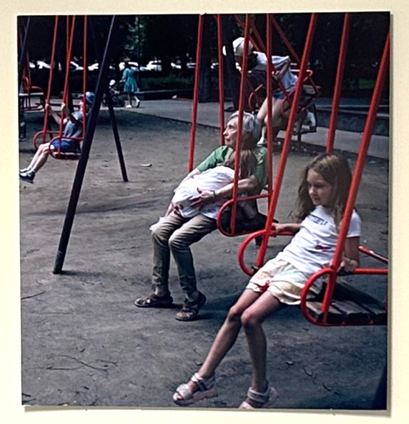
Lines of Time– lines of time form around generations of Ukrainians.
25 x 25 Digital Pigment Print. $250
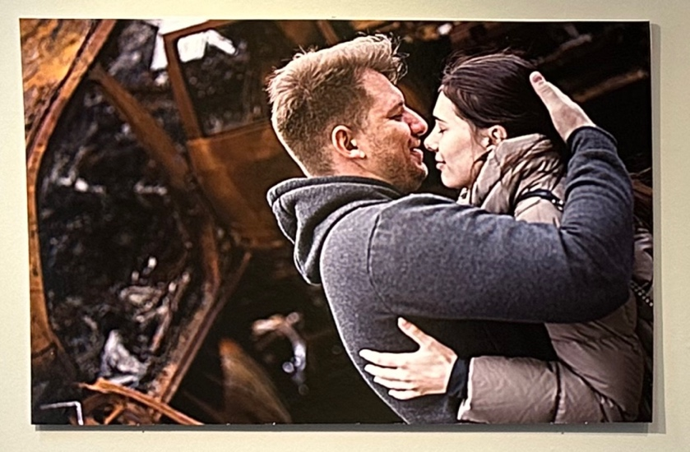
Love in the Car Graveyard – photographer and model caught in their own camera outside their bombed apartment building in Irpin. 24 x 36 Digital Pigment Print. $450
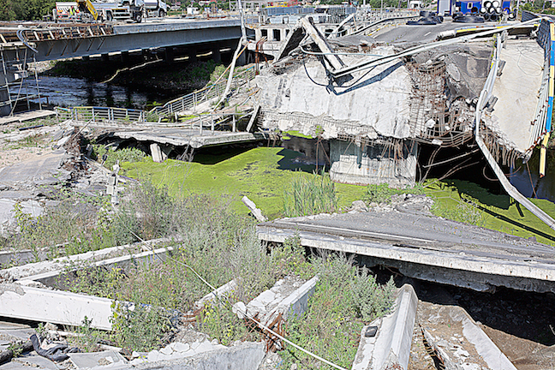
Broken Bridge at Irpin—the Monument to the Refugees captured on the nightly news fleeing from the Russian invasion. 24 x 36. $500

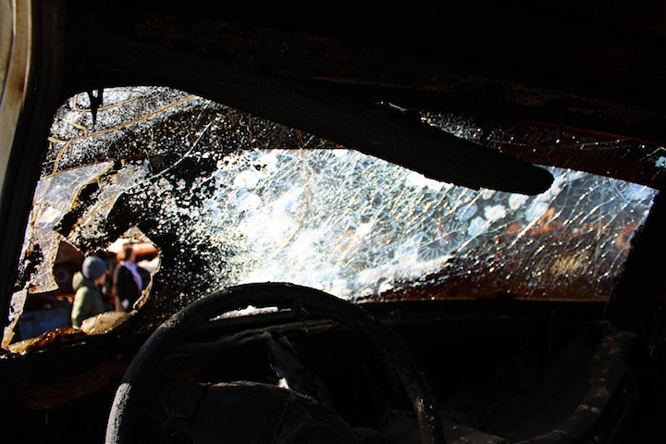
Inside-Out, through the windshield of one of the thousands of civilian vehicles destroyed by Russian fire - 24 x 36 Digital Pigment Print. $400
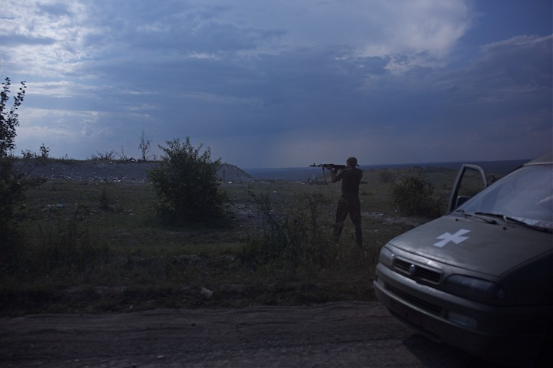
Making Contact – fire breaks out on the fluid front lines near Bakhmut - 24 x 36 Digital Pigment Print. $200
Irina –stayed in her home, next door a house leveled by Russian shelling near Kherson, in liberated territory, but still dotted with Russian mines. 24 x 36. $450

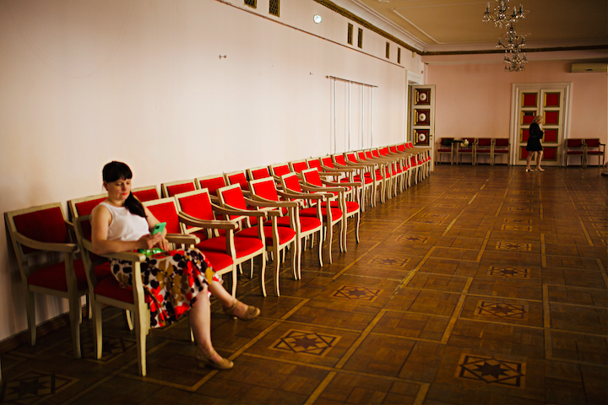
Empty seats at the Philharmonie – missing people occupied by space. 24 x 36 Digital Print. $300

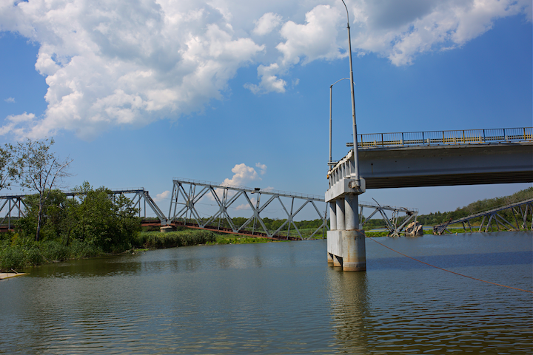

Broken bridge at Lyman – site of the Ukrainian breakthrough in the fall of 2022. 24 x 36 print. $300

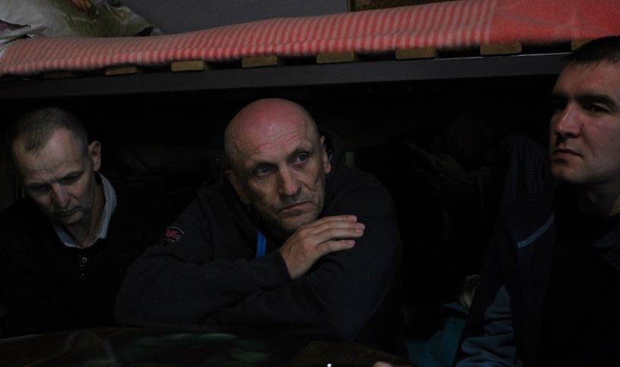
Halfway house in Vinnytsia – PTSD fresh from the front lines. 24 x 36 Digital Pigment Print. $300
Never too Close—at the Philharmonie after the giant missile attack in Khmelmytski. 24x36. $400.

Heroes of Ukraine—memorial at Khmelnytski municipal plaza. 36x24. $400.

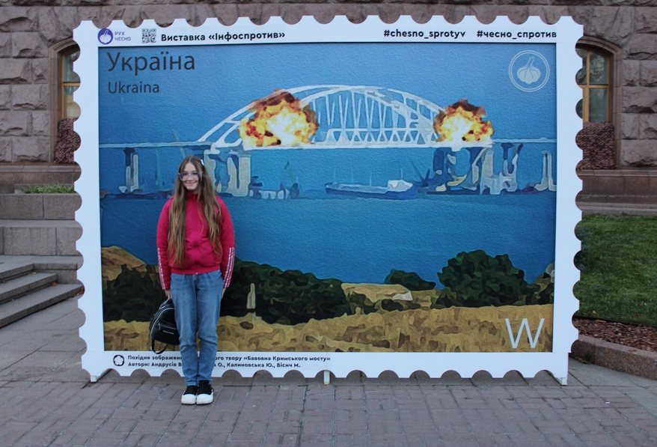
Burning Bridge –posing in front of commemorative stamp. 24x36. $350

Smoke—military intelligence comrades at rest in Kupiansk. 24x36. $350.

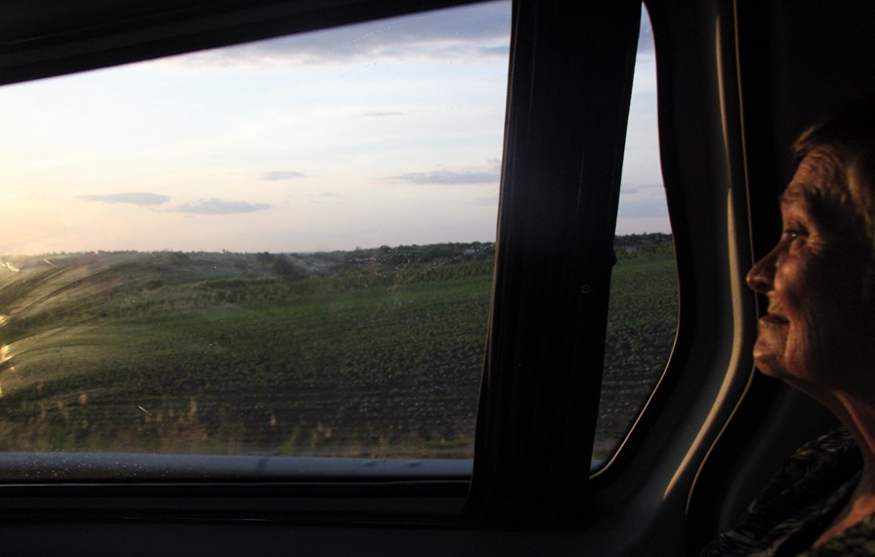
Coming home—refugee leaving Kherson. 24x36. $250

Ancient Kingdom—from the Pecharska Lavra. 24x36. $400.

Roses for the Hero—commemoration for fallen soldier at Khmelnytski. 36x24. $450.

Ancient Heroes—frieze from the Pecharska Lavra. 40x60. $600

The Druid—mural under the bridge at Dnipro. 40x60. $600

Helpless in the Dust –fallout from the skies near Bakhmut. 40x60. $600

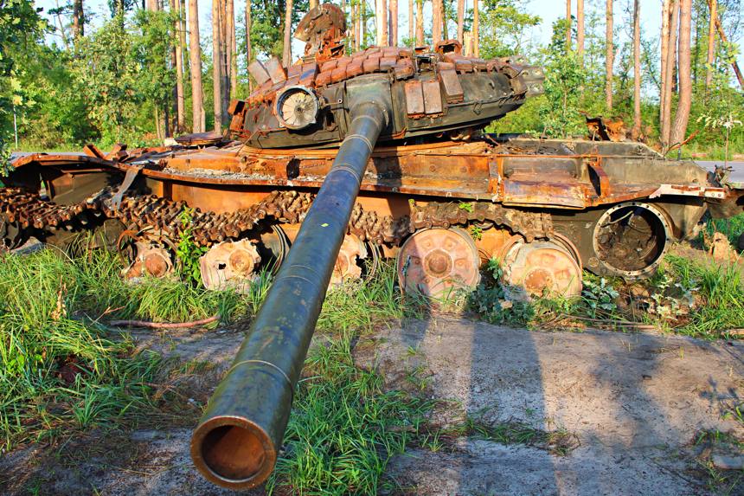
Burnout – fire-saturated remains of tank destroyed near Bucha. 40x60. $750.
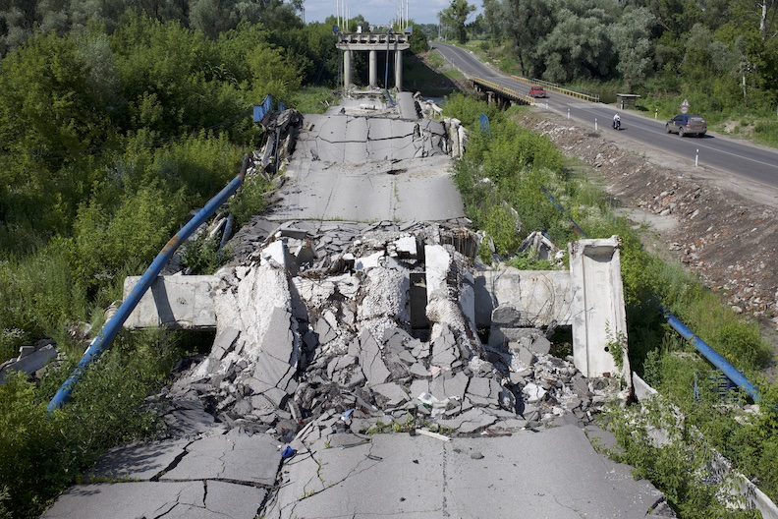
Interruptus—broken bridge near Izium. 40x60. $600

